

**PRIMARY ONE MATHEMATICS SET II 2020.**

1. **Name these shapes.**
2. ______________ (b)

( c )

1. **What number comes before and after?**
2. _____, 9, ____ d) _____, 7, _____
3. _____, 5, _____ e) _____, 12, ____
4. _____, 2, _____
5. **Match correctly.**
6. 9 fifteen
7. 15 eleven
8. 5 nine
9. 11 five
10. **How many groups of 2 can you see?**



1.  =

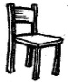

b) =



1. **Form groups of 3 and then write the answer.**

(a)

= 4 groups

= groups

1. = groups
2. 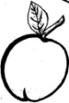

 = groups

1. **Circle the correct word.**
2. sqaure, sqreau, square
3. four, foru, fuor
4. theer, trhee, three
5. **How many can you count?**

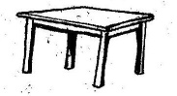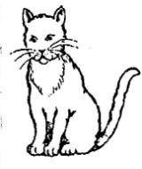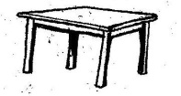



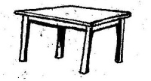

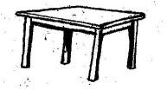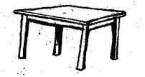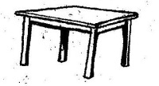



1. How many can you count? _________
2. How many can you count? __________
3. 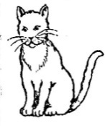How many can you count? __________
4. 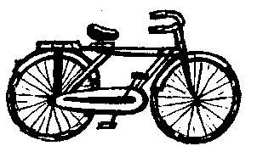**Cross out and make them 3.**

(a)

(b) Z Z Z Z Z Z Z

( c)

1. **Fill in the missing letters.**
2. Mo__day
3. F__ve
4. Ei__ht
5. __en
6. **Arrange from smallest to biggest.**
7. 0, 4, 2, 1

_________________________________________

1. 5, 4, 2, 3

_________________________________________

1. 8, 7, 9, 6

_______________________________________

1. **Write “Yes” or “No”.**
2. Four plus three equals five. _________________
3. This is a triangle. __________________
4. 9 - 5 = 4 _________________
5. 2 x 2 = 4 _________________
6. 2 x 5 = 7 _________________
7. **Fill in the missing numbers.**
8. _____ + _____ = 3
9. _____ + _____ = 5
10. _____ + _____ = 2
11. _____ + _____ = 6
12. **Complete the abacus.**
13. T O

= _________________

1. T O

= _____________

1. T O

= _______________

1. **Draw beads on the abacus.**

T O T O

1. (c)

1 2 4 5

1. T O (d) T O

5 3 3 3

1. 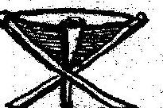**Complete correctly.**



(a)

There are ________ stools. Each stool has _______

legs. They have _______ legs.

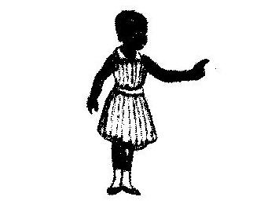

(b)

There are ______ girls. Each girl has ______ legs. They

have ______ legs.

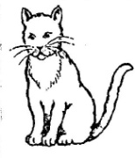

( c)

There are ________ cats. Each cat has ______ ears.

They have _________ ears altogether.

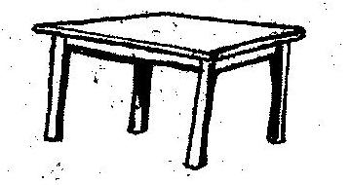

(d)

There are _______ tables. Each table has _______

legs. They have _________ legs altogether.

1. **What is the time**

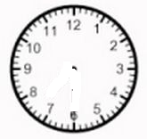

1. It is __________ O’clock.



1. It is __________ O’clock.



(c ) It is _________ O’clock.



(d)

It is __________ O’clock.

1. Write the shaded parts (fractions).

1. = 1 (c) = __

4

1. = _____ (d) _______
2. Shade the given fractions.

2 =

1. 3
2. 2 =

6

1. 3 =

5

1. 3 =

7

1. Use set X and set Y to answer the questions that

follow.

X Y

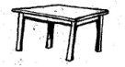 A B

 C D

E F

1. Name set Y.
2. Name set X.
3. How many members are in set X?
4. Which set has more members?
5. How many members do both sets have altogether?
6. **Use the graph below to answer the questions.**



Joan



 Peter



Mary



Joy

**Questions:**

1. _______________ has 5 balls.
2. Mary has ________ balls.
3. ____________ and ____________ have the same number of balls.
4. Who has the smallest number of balls?
5. How many balls do they have altogether?



**P. 1 ENGLISH PAPER (SET II) 2020.**

Name: ____________________________ Stream: _____

1. Name the pictures given below.

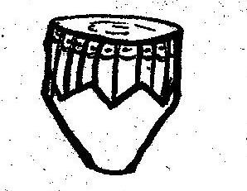

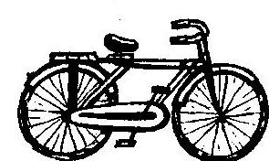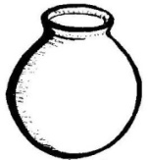

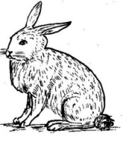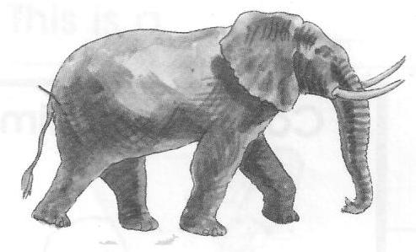

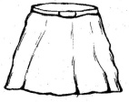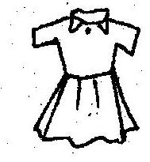

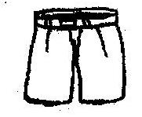

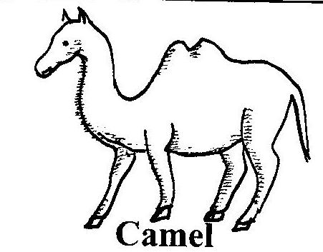

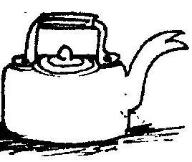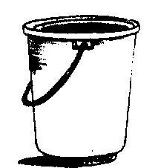

1. **Fill in the table correctly with the words given below.**

cassava, skirt, blue, matooke, shirt, yellow, rice,

trousers, red, pumpkin, jacket, pink, sweet potatoes, sweater, green, yams, dress, purple

|  |  |  |
| --- | --- | --- |
| Food | Clothes | Colours |
|  |  |  |
|  |  |  |
|  |  |  |
|  |  |  |
|  |  |  |
|  |  |  |

1. Fill in the missing letters.
2. ___, ___roplane (b) h__rse

c) dr__m (d) b __ __ k

e) w__nd__w (f) B __ble

g) needl___ (h) w__m___n

i) t___ach__r (j) bla___kb___ __rd

1. Where is the ________________?

( on, in, under, near, behind, infront of, over )

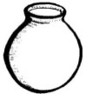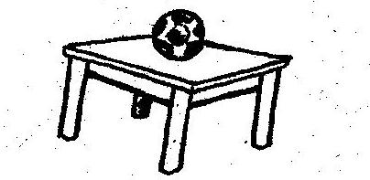

a)

The pot is on the table.

b)

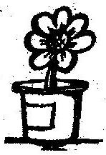 The ____________ is _____the __________

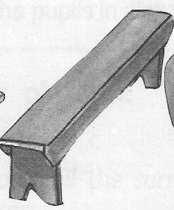

c ) The _______ is _________ the __________

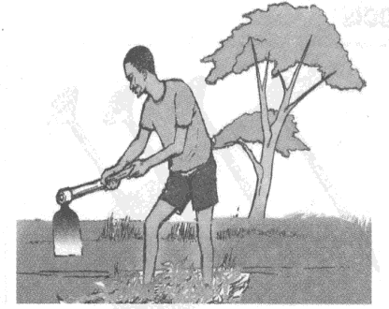

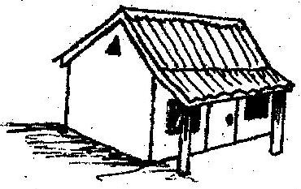

1. The __________ is behind the _________



1. 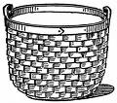 The ________ is near the ____________
2. 

The ___________ is ______ the ________

1. **Tick the word with correct spelling.**
   1. twe two tow
   2. carring carying carrying
   3. elephaunt elephant elepant
   4. bottle bottel botle
   5. pineappel pineapple pinapple
   6. moth muoth mouth
   7. shirt shrit shart
   8. Tuesday Teusday Tusedy
   9. teer tree tere
   10. baskt basket baskit
2. **Use a, an, is or ‘are’ to complete the sentences correctly.**
3. I have ________ nice dress.
4. Namuli is eating _______ apple.
5. Mum _____ sitting on the mat.
6. There ________ many oranges in the basket.
7. Teddy has ____________ umbrella.
8. The teacher _________ writing on the chalkboard.
9. My father has __________ big car.
10. The children ____________ eating pineapples.
11. **Complete these sentences with the correct words.**

( needle, broom, hoe, stick, rake, swimming )

1. Hannah is sweeping the house with a _____________
2. Mr. Kato is digging in the garden with a ___________
3. The man is killing a snake with a _______________
4. Teacher Mary is collecting rubbish with a ________
5. Ann is sewing her table cloth with a _____________
6. Primary One pupils are ______________ in the water.
7. **Read these sentences correctly then rewrite them.**
8. Go and sweep your classroom.

…………………………………………………………………….

1. Come here and read with me.

…………………………………………………………………….

1. Stop playing in your classroom.

…………………………………………………………………….

1. That is a good dress.

…………………………………………………………………….

1. Tom is climbing a tree.

…………………………………………………………………….

1. The small goat is brown.

…………………………………………………………………….

1. **Circle the words starting with a vowel.**
2. Hen bag desk egg
3. Ink bottle box chair
4. Nose neck ear head
5. Pencil orange desk broom
6. Store kitchen apple bed
7. **Write in small letters.**

DUSTER - ____________________

OPEN - ____________________

BLACKBOARD - ____________________

PLATES - ____________________

1. **Find a small word.**

Bank - ______________________

Teacher - ______________________

Bedroom - ______________________

1. Form a correct word.

hair 1. chair

hurch 2. _______________

С oat 3. _______________

at 4. ________________

ook 5. ________________



b. 1. stool



2. ___________________

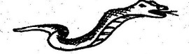 S

3. ___________________

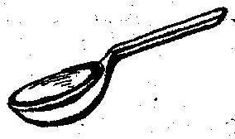

4. ____________________



5. ___________________

c.

ish 1. _______________

lower 2. ________________

f lask 3. _______________

ather 4. ________________

1. Count and write the numbers in words.

_____________ balls



_____________ cups

______________ stars

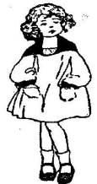

______________ girls

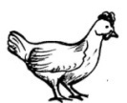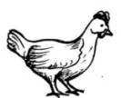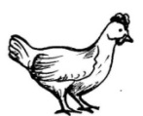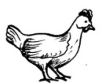

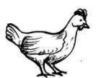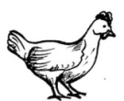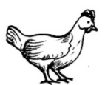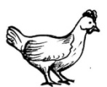 __________ hens

1. **Write out wild animals.**

cow 1. ________________

basket girl

fox elephant 2. ________________

flower boy

lion sheep 3. _________________

4. _________________

1. **Write these words correctly.**

codilecro - ________________________

leppa - ________________________

rac - ____________________

tere - ____________________

poons - ____________________

thermo - ____________________

malani - ____________________

inctse - ___________________

1. Seven words are in the box. Find them in the puzzle and circle them.

e y e b a h q 1. eye

f b t d e o o 2. ______________

t r e e a e t 3. ______________

b d m h r o m 4. _______________

f g r b m a n 5. ______________

e t d o r p d 6. _______________

o d f y n o x 7. _______________

1. **Write sentences out of the table.**

|  |  |  |
| --- | --- | --- |
| She | is | washing her clothes.  peeling matooke.  mopping the house.  eating a banana.  cleaning the compound. |

* + 1. She is washing her clothes.
    2. .…………………………………………………………
    3. ………………………………………………………….
    4. ………………………………………………………….
    5. ………………………………………………………….

1. **Read the story and answer the questions correctly.**

Peter lives at Kisugu village. He has a dog. His dog is called Kitty. Kitty is a good dog. Everyday Kitty barks at the thieves and they run away. Everyone at home likes Kitty. Everyday Peter gives Kitty some milk. Kitty likes Peter. Peter’s father buys meat for Kitty.

**Answer the questions.**

1. Who has a dog?

……………… has a dog.

1. Where does Peter live?

Peter lives at ……………………………….

1. What is the name of Peter’s dog?

The name of Peter’s dog is …………………

1. Who buys meat for Kitty?

…………………. buys meat for Kitty.

1. What does Kitty do to the thieves?

Kitty ………………… at the thieves.

‘**STAY WELL’**



**PRIMARY ONE LITERACY I**

1. Name these garden tools.



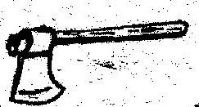

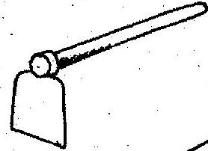

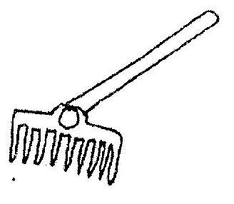

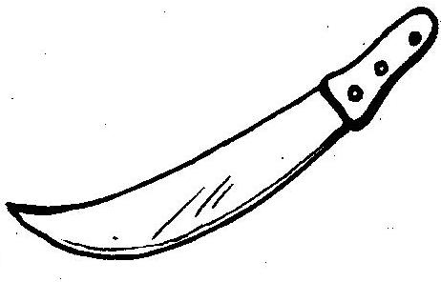

1. How are the following garden tools useful to a farmer?



(a)

A hoe for ________________

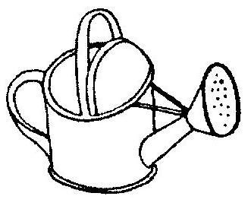

(b)

A watering can for _____________



( c)

A rake for ___________________

1. Name the object that gives us light during day time.

………………………………………………………………………………

1. Name any one place where we can get water.

……………………………………………………………………………

1. Write any one item we use to wash our hands.

………………………………………………………………………………

1. Name the health habit done before eating food.

………………………………………………………………………………

1. Name these things we use on a sunny day.

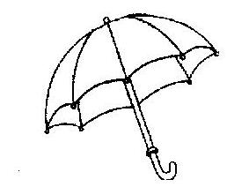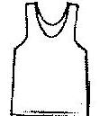



1. Write any one tree that provides fruits.

……………………………………………………………

1. 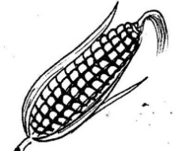Name these foods eaten at home.

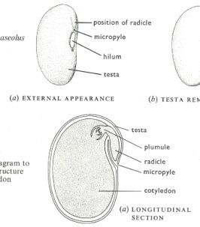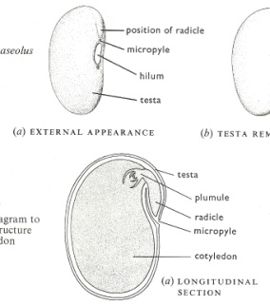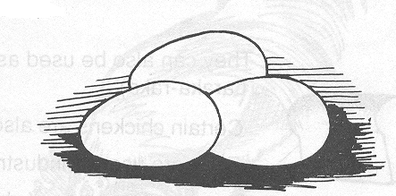

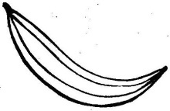

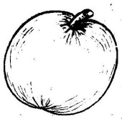

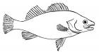

1. **Draw these living things.**

|  |  |  |
| --- | --- | --- |
| bird | flowers | banana plant |
|  |  |  |

1. Write any one activity done in the garden.

…………………………………………………………

1. Which item do you use to dry your body after bathing? ……………………………………………...
2. Name these dangerous objects.

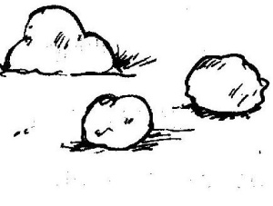

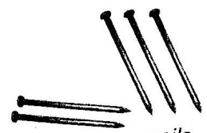



1. Why is it bad to play with a knife?

…………………………………………………………

1. Who heads a family when the father is not at

home?………………………………………………

1. Name these needs of family members.

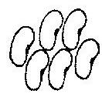

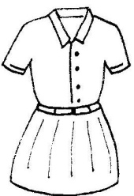





1. What do you use to sweep your classroom?

…………………………………………………………

1. Why do we need water?

…………………………………………………………

1. Write any one item used to make a ball.

…………………………………………………………

1. Match animals to their young ones.

A cow puppy

A dog calf

A person kitten

A cat baby

A sheep chick

A hen lamb

1. Name any one product got from a hen.

………………………………………………………

1. Why do people keep dogs at home?

…………………………………………………………

1. Name any one place where people go for

medical care. …………………………………………………………………………

1. Who treats sick people in the community?

…………………………………………………………………………..

1. Why should homes have charcoal stoves?

………………………………………………………………………..

1. Write one item your school uses for cooking.

………………………………………………………………………..

1. Match the following objects with the materials from which they are made.

skin

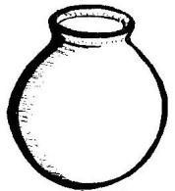

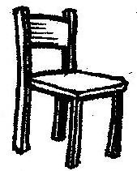wood

banana fibres

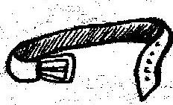

clay

1. Which animal hisses?

………………………………………………………….

1. Write any one body sense.

…………………………………………………………

1. Name any one thing found in a good home.

…………………………………………………………



**PRIMARY ONE LITERACY II**

1. Write any two people found in the school community.

(i) ……………………………………………………

(ii) ……………………………………………………

1. Name these important places found in the community.

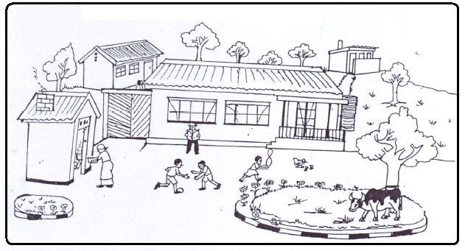

1. Who makes furniture in our community?

…………………………………………………………………

1. What is the work of a pilot?

…………………………………………………………………

1. Name these activities done in our community.

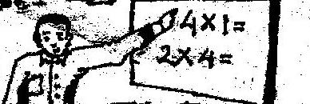(a)

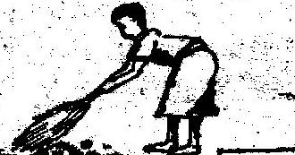(b)

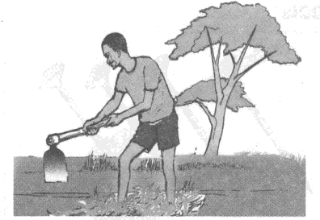

(c)

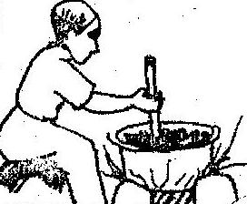

(d)

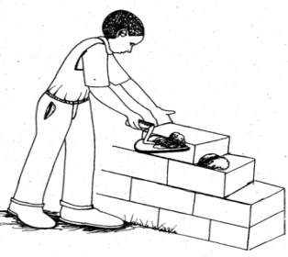

1. **Circle the correct word.**
2. school shool shcool
3. unifrom uniform unifom
4. singpost sinpost signpost
5. 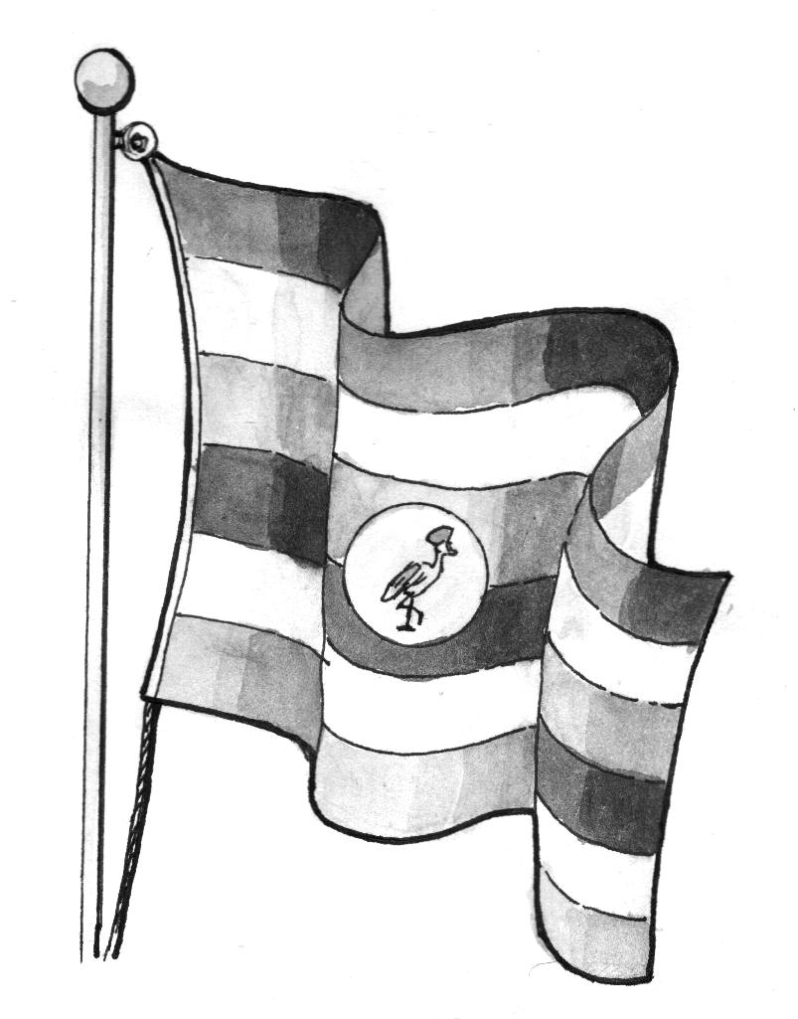bage badge bagdge

Name these things found in the school compound.



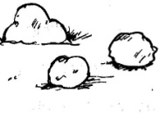

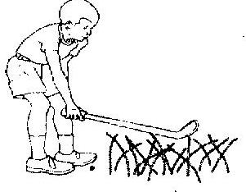

1. Name the traffic lights.

orange

1. What do you call the woman who produced you?

……………………………………………………………………………….

1. Underline the domestic animals.

goat, rat, lamb, snake, lizard, cow

1. Why do we need chairs in our classrooms?

……………………………………………………………………………….

1. Why does a teacher need chalk?

………………………………………………………………………………

1. Write any one item we sit on at home.

……………………………………………………………………………….

1. 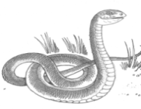Name this wild animal.
2. 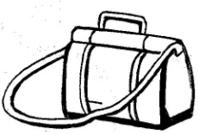Name these things made out of animal skins.

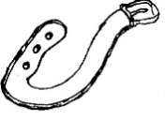

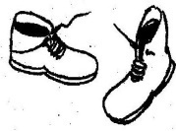

1. Which animal barks for protection?

………………………………………………………………………………

1. Name these things we make.

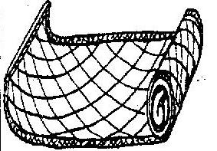

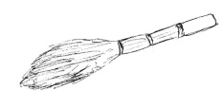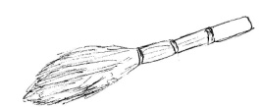

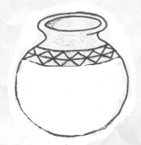

1. What do children use for skipping?

………………………………………………………………………………..

1. Which items are made out of wood in your

classroom? Give two.

(i) ………………………………………………………….

(ii) …………………………………………………………

1. Name the object sounded when it is time for meals.

……………………………………………………………………………….

1. Write any one game played on sports day.

………………………………………………………………………………..

1. Give any two family members.

(i) ………………………………………………………..

(ii) ………………………………………………………..

1. Mention any two activities done by children at

School.

(i) ……………………………………………………………

(ii) …………………………………………………………..

1. Write **Yes** or **No**.
2. Fire can burn. ………………………..
3. A hoe can pierce. ………………………
4. We go to school to learn. ………………………….
5. A school uniform makes us shabby. ……………..
6. Where do Christians go for prayers?